

User Guide for the Green Space Equity Mapper

Introduction
The Chesapeake Conservation Partnership (CCP) is a coalition of diverse organizations and agencies engaged in land conservation and related fields within the Chesapeake Bay watershed. CCP fosters collaborative action to conserve culturally and ecologically important landscapes to benefit people, economies and nature throughout the watershed. To further these goals, CCP has created the Green Space Equity Mapper to help prioritize conservation in low-income communities and communities of color with limited access to open space throughout the watershed. This web-based map tool includes a set of interactive map layers to help conservation organizations and community groups identify areas most in need of green spaces and how these gap areas relate to demographics, community risks and land cover. This User Guide includes instructions for navigating the tool as well as links to more resources.
Click here to access the tool.
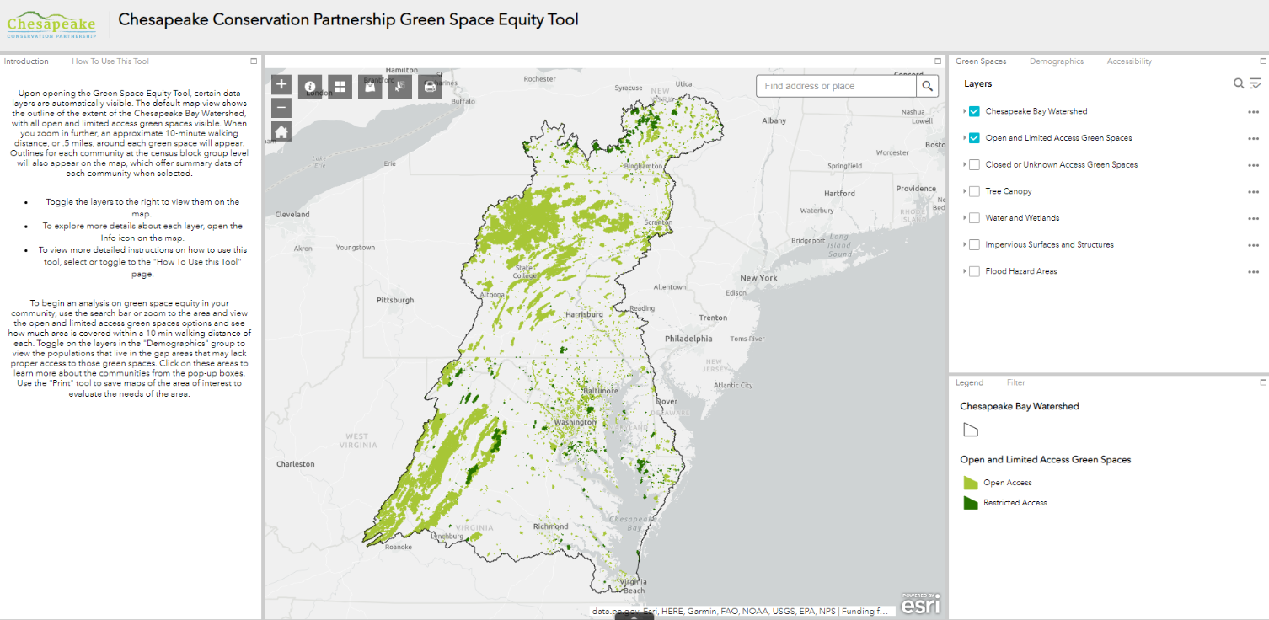
Click here to watch a brief instructional video.

Map Layers
The map layers within the Green Space Equity Mapper are grouped into the following three categories:
- Green Spaces contains Open and Limited Access Green Spaces, Closed and Unknown Access Green Spaces, Flood Hazard Areas and Land Cover information on tree canopy, impervious surfaces, structures, and water and wetlands.
- Demographics contains information on people of color, low income, a combined people of color and low-income demographic index, linguistic isolation, low life expectancy, under age 5, and over age 64 populations at the census block group level. The CDC also has a map layer for a Social Vulnerability Index that combines social and economic risks.
- Accessibility has map layers for an approximate 10-minute and 5-minute walking distance around all Open and Limited Access green spaces, and a 10-minute driving distance around those in rural areas. Map layers for Green Space Acres Per Capita in each block group, the Acres of Green Space solely within each block group, a Walkability Index metric and distances to the nearest transit stop.
More information on the map layers and sources are outlined on page 4.

Mapper Functions
Information Panels
The “Introduction” tab. provides a brief overview on how to navigate within the tool The “How To Use This Tool” tab provides a short 11 step guide that walks through each function in the tool.
Map Data Layers
To turn each map layer on and off, check and uncheck the box to the left of the layer name. Some layers may only be visible when zoomed in or out. If the layer you are interested in exploring is in light gray text, try zooming in or out until it becomes visible. Click on any feature in the map to see a pop-up box with a summary of the relevant information and links to more content. Select the up arrow at the bottom of the map to view any data in a table format. To export the search results, select “Options” in the top left corner of the table and then select “Export to CSV”.
Legend
The legend is shown in the lower right for active map layers. This will change dynamically according to the map layers turned on.
Filter
To filter datasets, set the parameters in the filter drop downs and toggle on the filter button. The create a custom filter, click the black icon in the lower right to set parameters on any dataset. The filter will reflect what is visible within the map.

Menu Bar
Access the tools below using the menu bar at the top left of the map.

Read detailed explanations and information on the sources of map data layers within each category.
Change the basemap within the tool. Choose from a range of background maps.
Add more geospatial data by searching for an online source, adding them from a URL or uploading a file.
Select one or more features on the map. Choose which layers to select from by checking and unchecking boxes next to the layer names.
Print the map on the current screen. You can change the map title, layout and export format.

Exploring Green Space Equity
To begin an analysis on green space equity in your community, use the search bar or zoom to the area to view the green spaces options available within a 10 min walking distance. Toggle on the layers in the "Demographics" group to view the populations that live in the green space gap areas that do not have green space within a 10-minute walk. Click on these areas in the map to learn more about the communities from the pop-up boxes. Another way to evaluate differences in green space is to toggle on the “total green spaces acres per capita” and “acres of green space within block groups” map layers. Areas lacking green space will appear in red and can be compared to the demographic and social vulnerability information. Additional data layers can also be added to view a range of factors such as climate risks, health factors, and more local contextual information. The “add data” button can be used to search by key words. Some sample key words and data layers to add are below:
 | Sample Key Words to Search | Potential Data Sources
Climate Risks | - “Seal Level Rise”  - “Temperature” or “Temperature Changes”  - “Heat” or “Urban Heat Island” | - NOAA: Sea Level Rise Inundation 1-10 ft  - EPA SEGS: U.S. Temperatures  - TPL: Urban Heat Island
Health Risks | - “EJSCREEN Environmental Indices”  - “AirNow”  - “CDC PLACES”  - “Food Access” | - EPA: EJSCREEN, AirNow monitoring  - CDC: PLACES Health measurements  - USDA ERS: Food Access by Census Tract
Local Data | City or Municipality name, with  - “Parcels”  - “Trails”  - “Zoning”  - “Infrastructure”, etc. | This will vary across states, localities and jurisdictions according to how much geospatial data is available.

Map Layer Descriptions and Sources
Map Layer | Description | Data Source
Green Spaces
Open and Limited Access Green Spaces | Data filtered according to the “Access” field: only Open and Restricted. | Chesapeake Conservancy adapted from the U.S. Geologic Survey (USGS) Protected Areas Database
Closed and Unknown Access Green Spaces | Data filtered according to the “Access” field: only Closed and Unknown.
Tree Canopy | Data filtered for Tree Canopy, Tree Canopy over Structures, Tree Canopy over Impervious Surfaces, and Tree Canopy over Impervious Roads | Chesapeake Conservancy: Conservation Innovation Center: Chesapeake Bay High-Resolution Land Cover
Impervious Surfaces | Data filtered for Structures, Impervious Surfaces, and Impervious Roads
Water and Wetlands | Data filtered for Water and Wetlands
Flood Hazard Areas | All FEMA designated areas for 1% Annual Chance Flood Hazard, Regulatory Floodway, Area with Reduced Risk Due to Levee, Special Floodway, Area of Undetermined Flood Hazard, Area of Minimal Flood Hazard, 0.2% Annual Chance Flood Hazard, and Future Conditions 1% Annual Chance Flood Hazard | Federal Emergency Management Agency (FEMA) Flood Insurance Maps
Chesapeake Bay Watershed | N/A | Chesapeake Bay Program
Demographics
People of Color | Full dataset according to the national percentile for people of color population for census block groups | EPA EJSCREEN Demographic Indicators
Low Income | Full dataset according to the national percentile for low-income population for census block groups | EPA EJSCREEN Demographic Indicators
Demographic Index | Full dataset according to the national percentile for demographic index for census block groups | EPA EJSCREEN Demographic Indicators
Linguistic Isolation | Full dataset according to the national percentile for linguistically isolated population for census block groups | EPA EJSCREEN Demographic Indicators
Under Age 5 | Full dataset according to the national percentile for under age 5 population for census block groups | EPA EJSCREEN Demographic Indicators
Over age 64 | Full dataset according to the national percentile for over age 64 population for census block groups | EPA EJSCREEN Demographic Indicators
Low Life Expectancy | Full dataset according to the national percentile for low life expectancy for census block groups | EPA EJSCREEN
Social Vulnerability Index | Full dataset according to the overall social vulnerability index score for each census tract. | CDC/ ATSDR Social Vulnerability Index
Counties | N/A | Chesapeake Bay Program
Census Block Groups | N/A | EPA EJSCREEN
Congressional Districts | Shown according to political party affiliation | ESRI
Accessibility
10-minute walk | Proxy for a distance walkable in 10 minutes around each open and limited access green space using a .5 mile buffer. | ArcPro .5 Mile Buffer Geoprocessing on “Open and Limited access Green Spaces” layer
5-minute walk | Proxy for a distance walkable in 5 minutes around each open and limited access green space using a .25 mile buffer. | ArcPro .25 Mile Buffer Geoprocessing on “Open and Limited access Green Spaces” layer
10-minute drive | Proxy for a distance drivable in 10 minutes around each open and limited access green space using a 5 mile buffer, in rural areas. | ArcPro 5 Mile Buffer Geoprocessing on “Open and Limited access Green Spaces” layer
Green Space Acres Per Capita | Total sum of open and limited access green spaces acres that are accessible within each census block group. | ArcPro Intersect and Sum Function on Census Block Groups for “Open and Limited access Green Spaces”
Acres Of Green Space within Census Block Group | Total sum of open and limited access green spaces acres that fall directly within each census block group. | ArcPro Zonal Sum Function on Census Block Groups for “Open and Limited access Green Spaces”
Walkability Index | Full dataset according to the overall walkability index score for each census block group | EPA Smart Location Database
Distance to Transit Stop | Full dataset according to the distance to the nearest transit stop from the population centroid for each census block group. | EPA Smart Location Database

